# Lab 3: Monitor the API

Lab 3: Monitor the API

Overview

Step 1: Viewing API Analytics

Step 2: Create a Custom Dashboard

Summary

## Overview

Anypoint Platform’s API Analytics provide the ability to keep track of key metrics like top users, transactions by region, usage by tier and performance against SLAs in a set of interactive, graphical dashboards and charts. You can create Custom Dashboards in a few clicks.

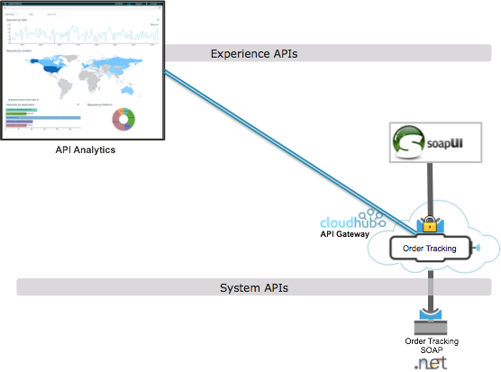

## Step 1: Viewing API Analytics

The API Analytics allow users to keep track of key metrics like top users, transactions by region, usage by tier and performance against SLAs in a set of interactive, graphical dashboards and charts.

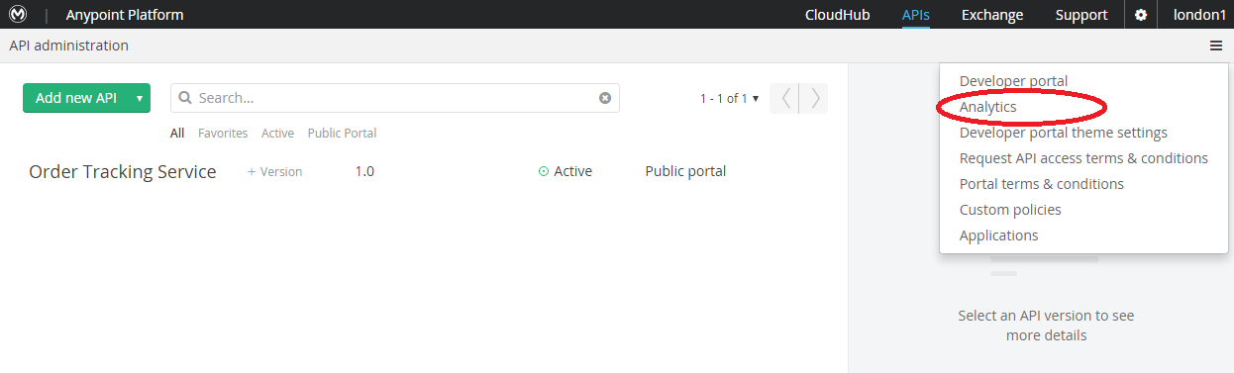

As an Organization Administrator, you have access to the Analytics Dashboards for your organization.

1. Navigate to the overview dashboard by clicking the **Analytics** link above the *Top 5 APIs* chart on your *API Administration* page.

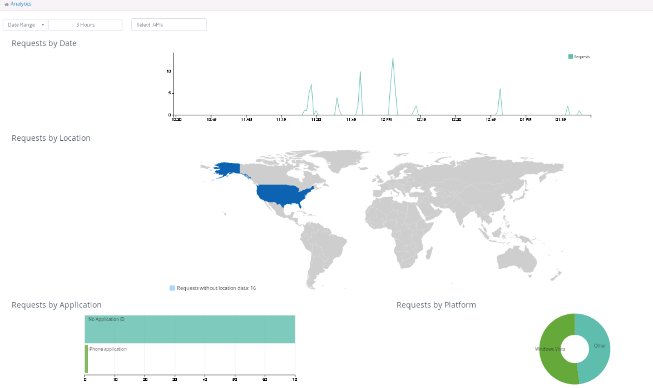

1. Zoom in on the last hours activity by selecting on **3 hours** for the Date Range.
2. When you access the Analytics for your organization, by default you land on your Overview Dashboard. This dashboard displays four standard charts:

·

* **Requests by Date**: Line chart that shows the number of requests for all APIs in your organization.
* **Requests by Location**: Map chart that shows the number of requests for each country of origin.
* **Requests by Application**: Bar chart that shows the number of requests from each of the top five registered applications.
* **Requests by Platform**: Ring chart that shows the number of requests broken down by platform.

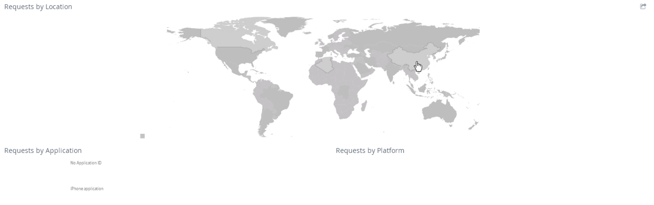

1. **Interactive Dashboard:** You can interact with the dashboards by clicking on the time range and dragging your mouse to create a custom time range. The overview dashboard graphs are linked together, so your custom time range could change the numbers and types of requests shown in the graphs at the bottom. For example, you can select a specific country, like China, to see only the requests from that specific location.

## Step 2: Create a Custom Dashboard

The overview dashboard provides an aggregate view of the API usage, but there is typically a need to see more detailed API utilization. The Anypoint Analytics platform allows user to create charts and build custom dashboards for more detailed information. In this step we’ll create a custom dashboard by building 4 custom charts, including viewing response time, response codes, requests by city and policy violations.

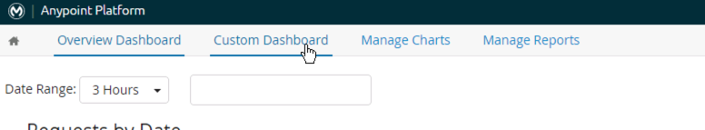

To create a custom dashboard

1. Click on the **Custom Dashboard** option in the menu on top.

Since you do not have any custom dashboard defined you are thrown right in to edit mode.

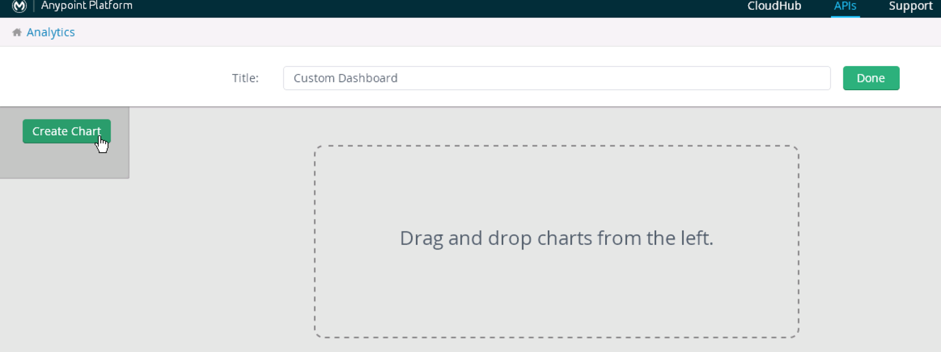

1. Select **Create Chart** and add a chart Title.

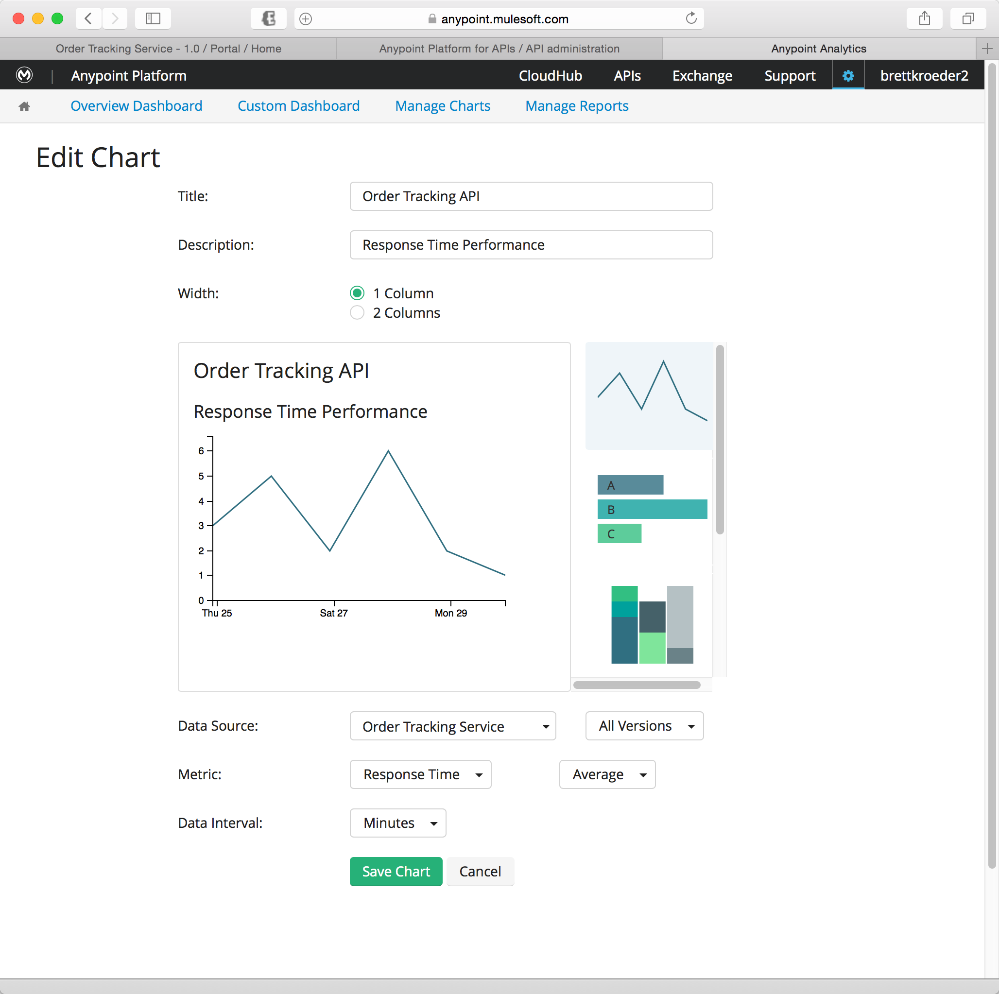

1. Specify the metrics to chart the **Response Time** for the **Order Tracking API** and how to aggregate the values as shown above.
2. When you’re complete select **Save Chart**.

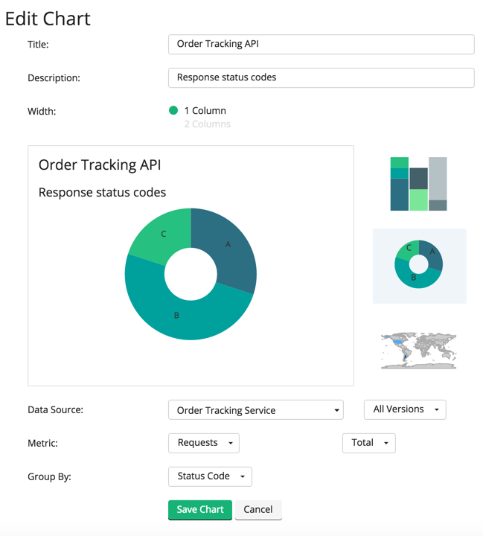

1. Add a chart to track Response Status Codes as shown above.

|  |
| --- |
| **NOTE**: Make sure to scroll down on the right side and pick the circular chart, not the default line graph. Otherwise you will not see the **Group By** option. |

1. Click **Save Chart**

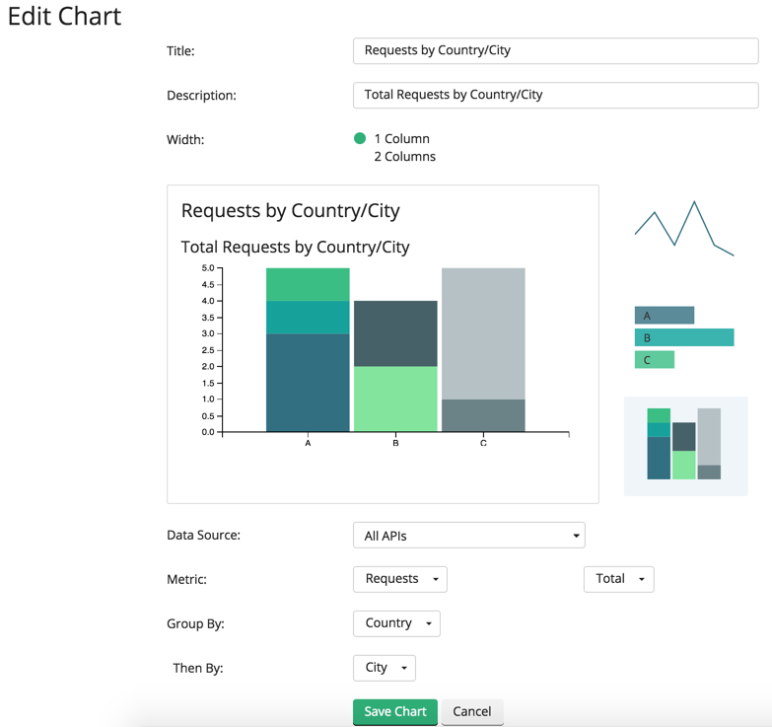

1. Create a chart with for the grouping request by country and city.
2. Click **Save Chart**

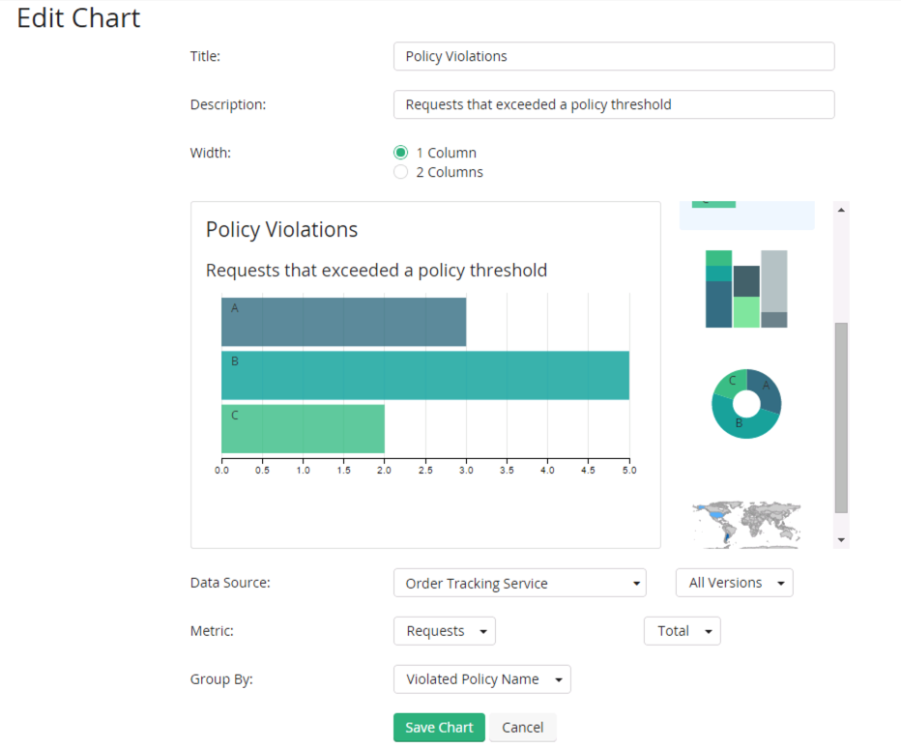

1. The last chart we will create is for measuring any request that have policy violations.
2. Click **Save Chart**

When you’re chart has been saved, it is available to be added to the canvas of your custom dashboard.

1. Drag and drop your newly created charts to the dashboard canvas

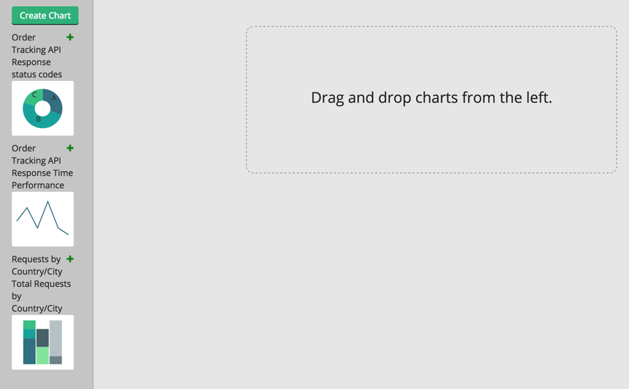

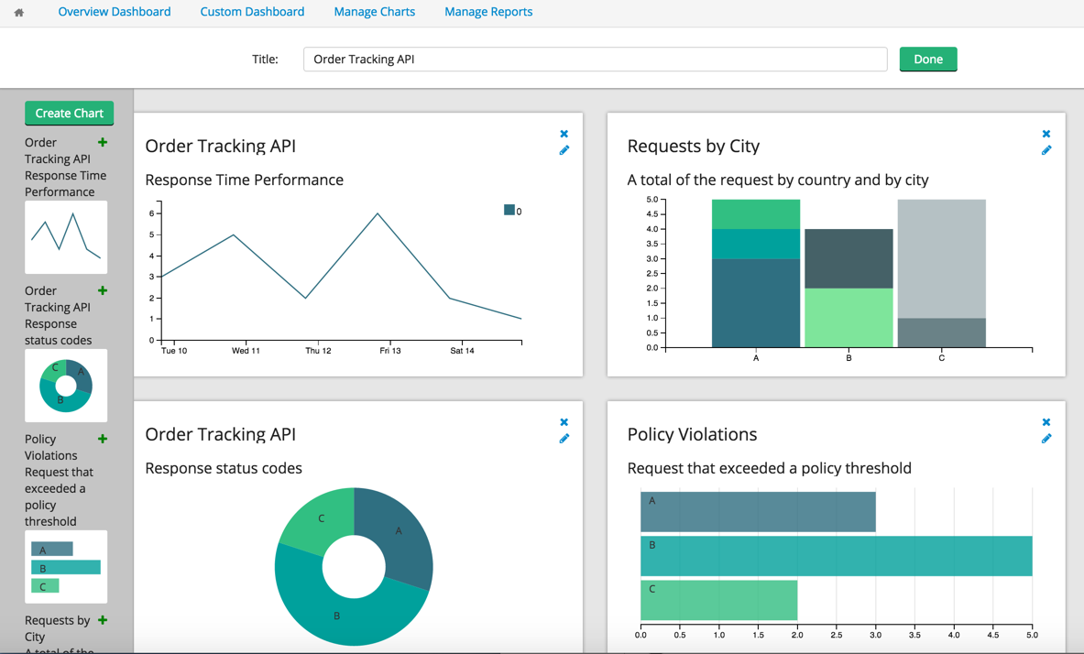

|  |
| --- |
| **NOTE**: If the drag-drop option doesn’t work on your browser, click on the green ‘+’ next to each chart on the left pane and it will get added to the canvas |

1. Click Done in the top right of the Dashboard editor.

You will now have a dashboard that will display metrics that are custom to your API.

## 

## Summary

In this lab, you were able to monitor your APIs using the built in API Analytics and Custom Dashboards. This provides **visibility** in you APIs so you can understand how your APIs are being consumed and utilized.

Additional details on creating custom dashboards and custom chart aggregations can be found in the Mule doc at *Viewing API Analytics*:

<http://www.mulesoft.org/documentation/display/current/Viewing+API+Analytics>.

Congratulations! You have finished Lab 3.

Please update the spreadsheet indicating you have completed Lab 3.